- State the null and alternative hypotheses for testing whether a new cashback offer on a food delivery app (like Zomato) has increased the average number of daily orders compared to before the offer.
ANSWERS:
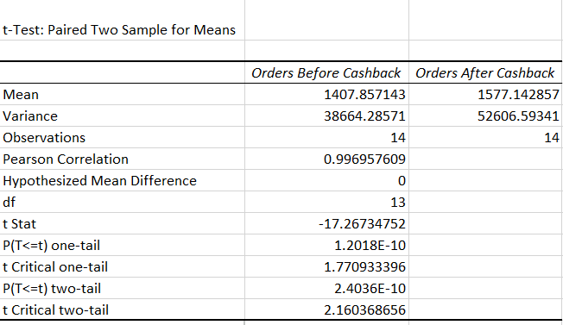
- Given the following scenario: A music streaming app claims their new playlist recommendation algorithm increases average listening time from 40 to 45 minutes. If you set up a hypothesis test, identify which type of error (Type I or Type II) would occur if you wrongly conclude the algorithm works when it actually doesn't, and explain in one sentence why.
ANSWERS:

- Suppose you run an A/B test on a shopping app (like Flipkart) and get a p-value of 0.03 when testing if a new discount banner increases purchases. At a 95% confidence level, state whether you reject or fail to reject the null hypothesis and explain what this means in the context of the app.
ANSWERS:

- For a cricket app's push notification feature, you want to be 99% confident that sending match alerts increases user engagement. Explain what the 99% confidence level means in this context, and how it affects your decision to accept or reject the feature.
ANSWERS:

